**Lab Report-01**

*Course Title: Computer Graphics Laboratory*

*Course Code: CSE-304*

*3rd  Year 1st Semester Examination 2022*

**Date of Submission**: 28.05.2023



**Submitted to-**

**Dr. Mohammad Shorif Uddin**

***Professor***

**Dr. Morium Akter**

***Associate Professor***

*Department of Computer Science & Engineering*

*Jahangirnagar University*

|  |  |  |  |
| --- | --- | --- | --- |
| **Sl** | Class Roll | Exam Roll | Name |
| 01 | 380 | 202192 | Sovon Mallick |

**Scan Conversion of a Point**

***Source Code:***

|  |  |
| --- | --- |
| #include<bits/stdc++.h>  #include<graphics.h>  using namespace std;  int main()  {  int x,y;  cout<<"Enter position: "; | cin>>x>>y;  int gd= DETECT,gm;  initgraph(&gd,&gm,"");  putpixel(x,y,WHITE);  getch();  closegraph();  return 0;  } |

***Output:***

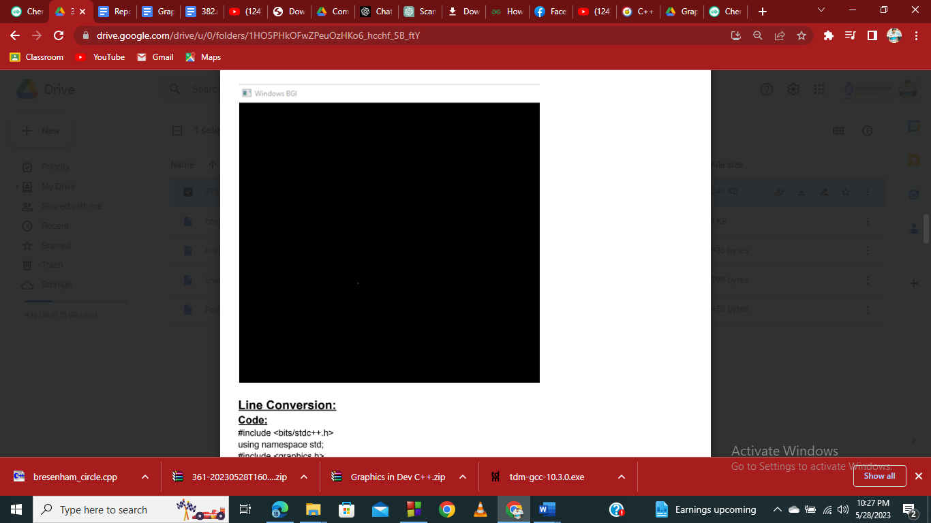

**Scan Converting Line using DDA Algorithm**

***Source Code:***

|  |  |
| --- | --- |
| #include<bits/stdc++.h>  #include<graphics.h>  #include<dos.h>  using namespace std;  int main()  {  int gd=DETECT;  int gm;  int x1,y1,x2,y2,dx,dy,steps,x_inc,y_inc;  initgraph(&gd,&gm," ");  cout<< "Enter starting co-ordinates: ";  cin>>x1>>y1;  cout<< "Enter ending co-ordinates: ";  cin>>x2>>y2;  dx=x2-x1;  dy=y2-y1;  if(abs(dx)>abs(dy))  { | steps=abs(dx);  }  else  steps=abs(dy);  x_inc=dx/steps;  y_inc=dy/steps;  for(int i=0;i<steps;i++)  {  putpixel(x1,y1,2.5);  x1=x1+x_inc;  y1=y1+y_inc;  }  getch();  closegraph();  } |

**Output:**

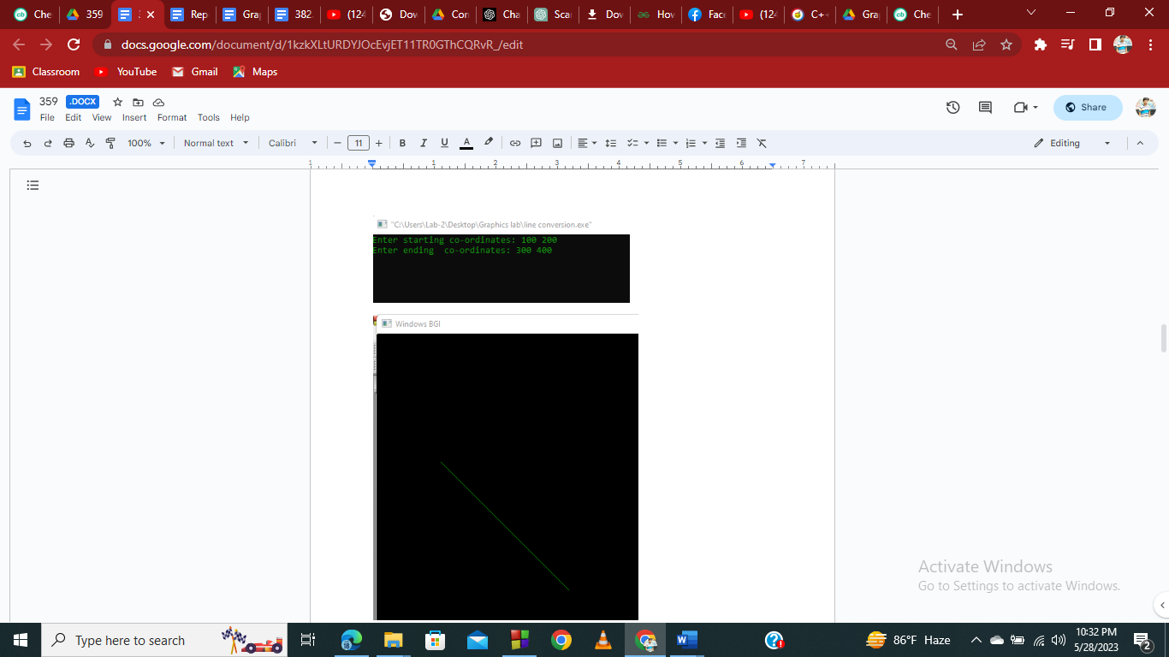

**Scan Converting Line using Bresenham Algorithm:**

***Source Code:***

|  |  |
| --- | --- |
| #include<stdio.h>  #include<graphics.h>  #include<bits/stdc++.h>  void drawline(int x0, int y0, int x1, int y1)  {      int dx, dy, p, x, y;      dx=x1-x0;      dy=y1-y0;      x=x0;      y=y0;      p=2*dy-dx;      while(x<x1)      {          if(p>=0)          {   putpixel(x,y,7);              y=y+1;              p=p+2*dy-2*dx; | }   else          {              putpixel(x,y,7);              p=p+2*dy;}   x=x+1;          }  }  int main()  {      int gd = DETECT, gm;     initgraph(&gd, &gm, "C:\\TC\\BGI");      int error, x0, y0, x1, y1;      printf("Enter co-ordinates of first point: ");      scanf("%d%d", &x0, &y0);      printf("Enter co-ordinates of second point: ");      scanf("%d%d", &x1, &y1);      drawline(x0, y0, x1, y1);      getch();      return 0;  } |

***Output:***

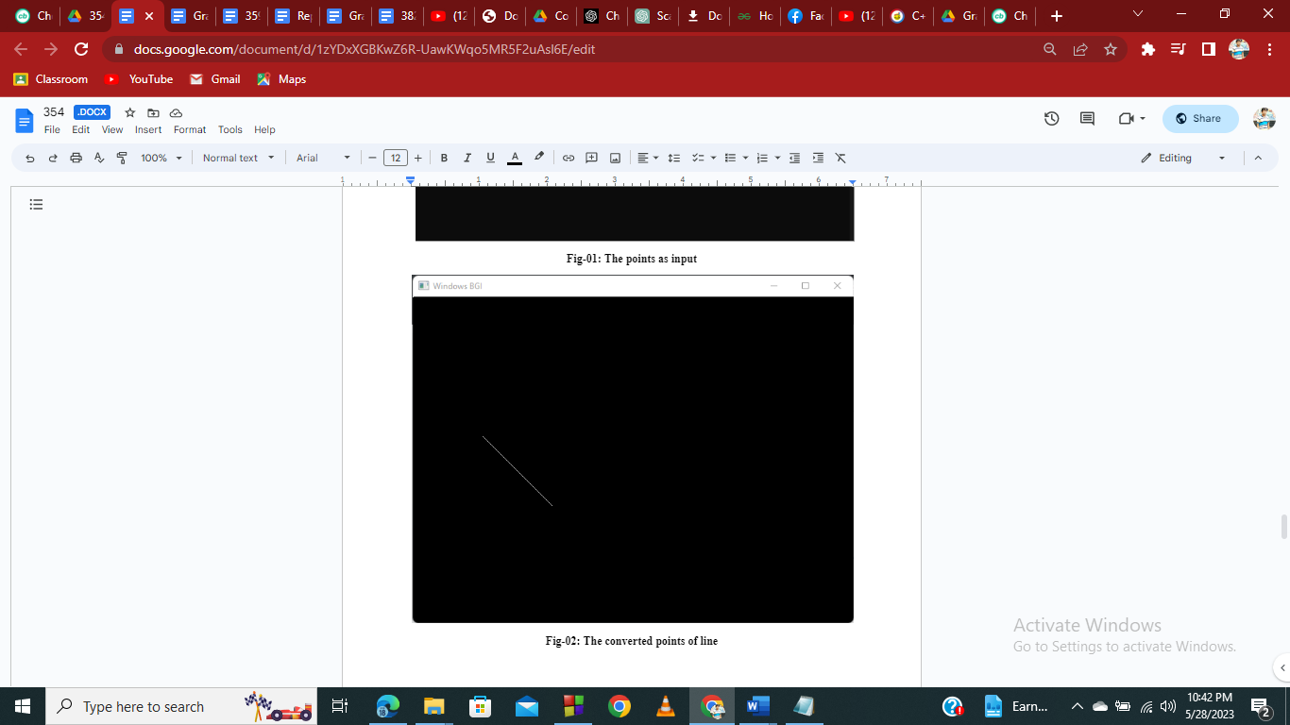

**Scan Converting a Circle**

***Source Code:***

#include <graphics.h>

void drawCircle(int xc, int yc, int radius) {

    int x = 0;

    int y = radius;

    int d = 3 - 2 * radius;

    while (x <= y) {

        putpixel(xc + x, yc + y, WHITE);

        putpixel(xc - x, yc + y, WHITE);

        putpixel(xc + x, yc - y, WHITE);

        putpixel(xc - x, yc - y, WHITE);

        putpixel(xc + y, yc + x, WHITE);

        putpixel(xc - y, yc + x, WHITE);

        putpixel(xc + y, yc - x, WHITE);

        putpixel(xc - y, yc - x, WHITE);

        if (d < 0)

            d += 4 * x + 6;

        else {

            d += 4 * (x - y) + 10;

            y--;

        }

        x++;

    }

}

int main() {

    int gd = DETECT, gm;

    initgraph(&gd, &gm, "");

    int xc, yc, radius;

    printf("Enter X coordiate of the center: ");

    scanf("%d", &xc);

    printf("Enter Y co-ordinate of the center: ");

    scanf("%d", &yc);

    printf("Enter the circle radius: ");

    scanf("%d", &radius);

    drawCircle(xc, yc, radius); // Draw the circle

    delay(5000); // Delay to show the output

    closegraph();

    return 0;

}

**Output:**

